PRÁCTICA #4
Problem A: Uncle Jack
Source file name: uj.c, uj.cpp or uj.java
Dear Uncle Jack is willing to give away some of his collectable CDs to his nephews. Among the titles you can find very rare albums of Hard Rock, Classical Music, Reggae and much more; each title is considered to be unique. Last week he was listening to one of his favorite songs, Nobody’s fool, and realized that it would be prudent to be aware of the many ways he can give away the CDs among some of his nephews.
So far he has not made up his mind about the total amount of CDs and the number of nephews. Indeed, a given nephew may receive no CDs at all.
Please help dear Uncle Jack, given the total number of CDs and the number of nephews, to calculate the number of different ways to distribute the CDs among the nephews.
Input
The input consists of several test cases. Each test case is given in a single line of the input by, space separated, integers N (1 <= N <= 10) and D (0 <= D <= 25), corresponding to the number of nephews and the number of CDs respectively. The end of the test cases is indicated with N = D = 0.
The input must be read from the file uj.in.
Output
The output consists of several lines, one per test case, following the order given by the input. Each line has the number of all possible ways to distribute D CDs among N nephews.
The output must be written to standard output.
Sample input
1 20
3 10
0 0

Output for the sample input
1
59049

Problem B
Equidivisions
Source file name: equidivisions.c, equidivisions.cpp or equidivisions.java

An equidivision of an n × n square array of cells is a partition of the n2 cells in the array in exactly n sets, each one with n contiguous cells. Two cells are contiguous when they have a common side.

A good equidivision is composed of contiguous regions. The figures show a good and a
wrong equidivision for a 5×5 square:

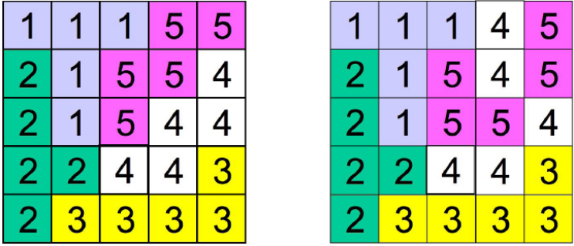

Note that in the second example the cells labeled with 4 describe three non-contiguous
regions and cells labeled with 5 describe two non-contiguous regions. You must write a program that evaluates if an equidivision of the cells in a square array is good or not.

Input
It is understood that a cell in an n×n square array is denoted by a pair (i, j), with 1 <=i, j <= n. The input file contains several test cases. Each test case begins with a line indicating n, 0 < n < 100, the side of the square array to be partitioned. Next, there are n − 1 lines, each one corresponding to one partition of the cells of the square, with some non-negative integer numbers. Consecutive integers in a line are separated with a single blank character. A line of the form
a1 a2 a3 a4 ...
means that cells denoted with the pairs (a1, a2), (a3, a4), ... belong to one of the areas in the partition. The last area in the partition is defined by those cells not mentioned in the n − 1 given lines. If a case begins with n = 0 it means that there are no more cases to analyze.
The input must be read from the file equidivisions.in.

Output
For each test case good must be printed if the equidivision is good, in other case, wrong must be printed. The answers for the different cases must preserve the order of the input.
The output must be written to standard output.

Sample Input | Output for the sample input
2 | wrong
1 2 2 1 | good
5 | wrong
1 1 1 2 1 3 3 2 2 2
2 1 4 2 4 1 5 1 3 1
4 5 5 2 5 3 5 5 5 4
2 5 3 4 3 5 4 3 4 4
5
1 1 1 2 1 3 3 2 2 2
2 1 3 1 4 1 5 1 4 2
4 5 5 2 5 3 5 5 5 4
2 4 1 4 3 5 4 3 4 4
0
Problem C
Generalized Matrioshkas
Source file name: matriosh.c, matriosh.cpp or matriosh.java
Vladimir worked for years making matrioshkas, those nesting dolls that certainly represent truly Russian craft. A matrioshka is a doll that may be opened in two halves, so that one finds another doll inside. Then this doll may be opened to find another one inside it. This can be repeated several times, till a final doll -that cannot be opened- is reached.
Recently, Vladimir realized that the idea of nesting dolls might be generalized to nesting toys. Indeed, he has designed toys that contain toys but in a more general sense. One of these toys may be opened in two halves and it may have more than one toy inside it. That is the new feature that Vladimir wants to introduce in his new line of toys.
Vladimir has developed a notation to describe how nesting toys should be constructed. A toy is represented with a positive integer, according to its size. More precisely: if when opening the toy represented by m we find the toys represented by n1, n2, . . ., nr, it must be true that n1 +n2 +. . .+nr < m. And if this is the case, we say that toy m contains directly the toys n1, n2, . . ., nr . It should be clear that toys that may be contained in any of the toys n1, n2, . . ., nr are not considered as directly contained in the toy m.
A generalized matrioshka is denoted with a non-empty sequence of non zero integers of the form:
a1 a2 . . . aN
such that toy k is represented in the sequence with two integers −k and k, with the negative one occurring in the sequence first that the positive one.
For example, the sequence
−9 − 7 − 2 2 − 3 − 2 − 1 1 2 3 7 9
represents a generalized matrioshka conformed by six toys, namely, 1, 2 (twice), 3, 7 and 9. Note that toy 7 contains directly toys 2 and 3. Note that the first copy of toy 2 occurs left from the second one and that the second copy contains directly a toy 1. It would be wrong to understand that the first −2 and the last 2 should be paired.
On the other hand, the following sequences do not describe generalized matrioshkas:
• −9 − 7 − 2 2 − 3 − 1 − 2 2 1 3 7 9
because toy 2 is bigger than toy 1 and cannot be allocated inside it.
• −9 − 7 − 2 2 − 3 − 2 − 1 1 2 3 7 − 2 2 9
because 7 and 2 may not be allocated together inside 9.
• −9 − 7 − 2 2 − 3 − 1 − 2 3 2 1 7 9
because there is a nesting problem within toy 3.

Your problem is to write a program to help Vladimir telling good designs from bad ones.
Input
The input file contains several test cases, each one of them in a separate line. Each test case is a sequence of non zero integers, each one with an absolute value less than 107.
The input must be read from the file matriosh.in.
Output
Output texts for each input case are presented in the same order that input is read.
For each test case the answer must be a line of the form
:-) Matrioshka!
if the design describes a generalized matrioshka. In other case, the answer should be of the form
:-( Try again.
The output must be written to standard output.
